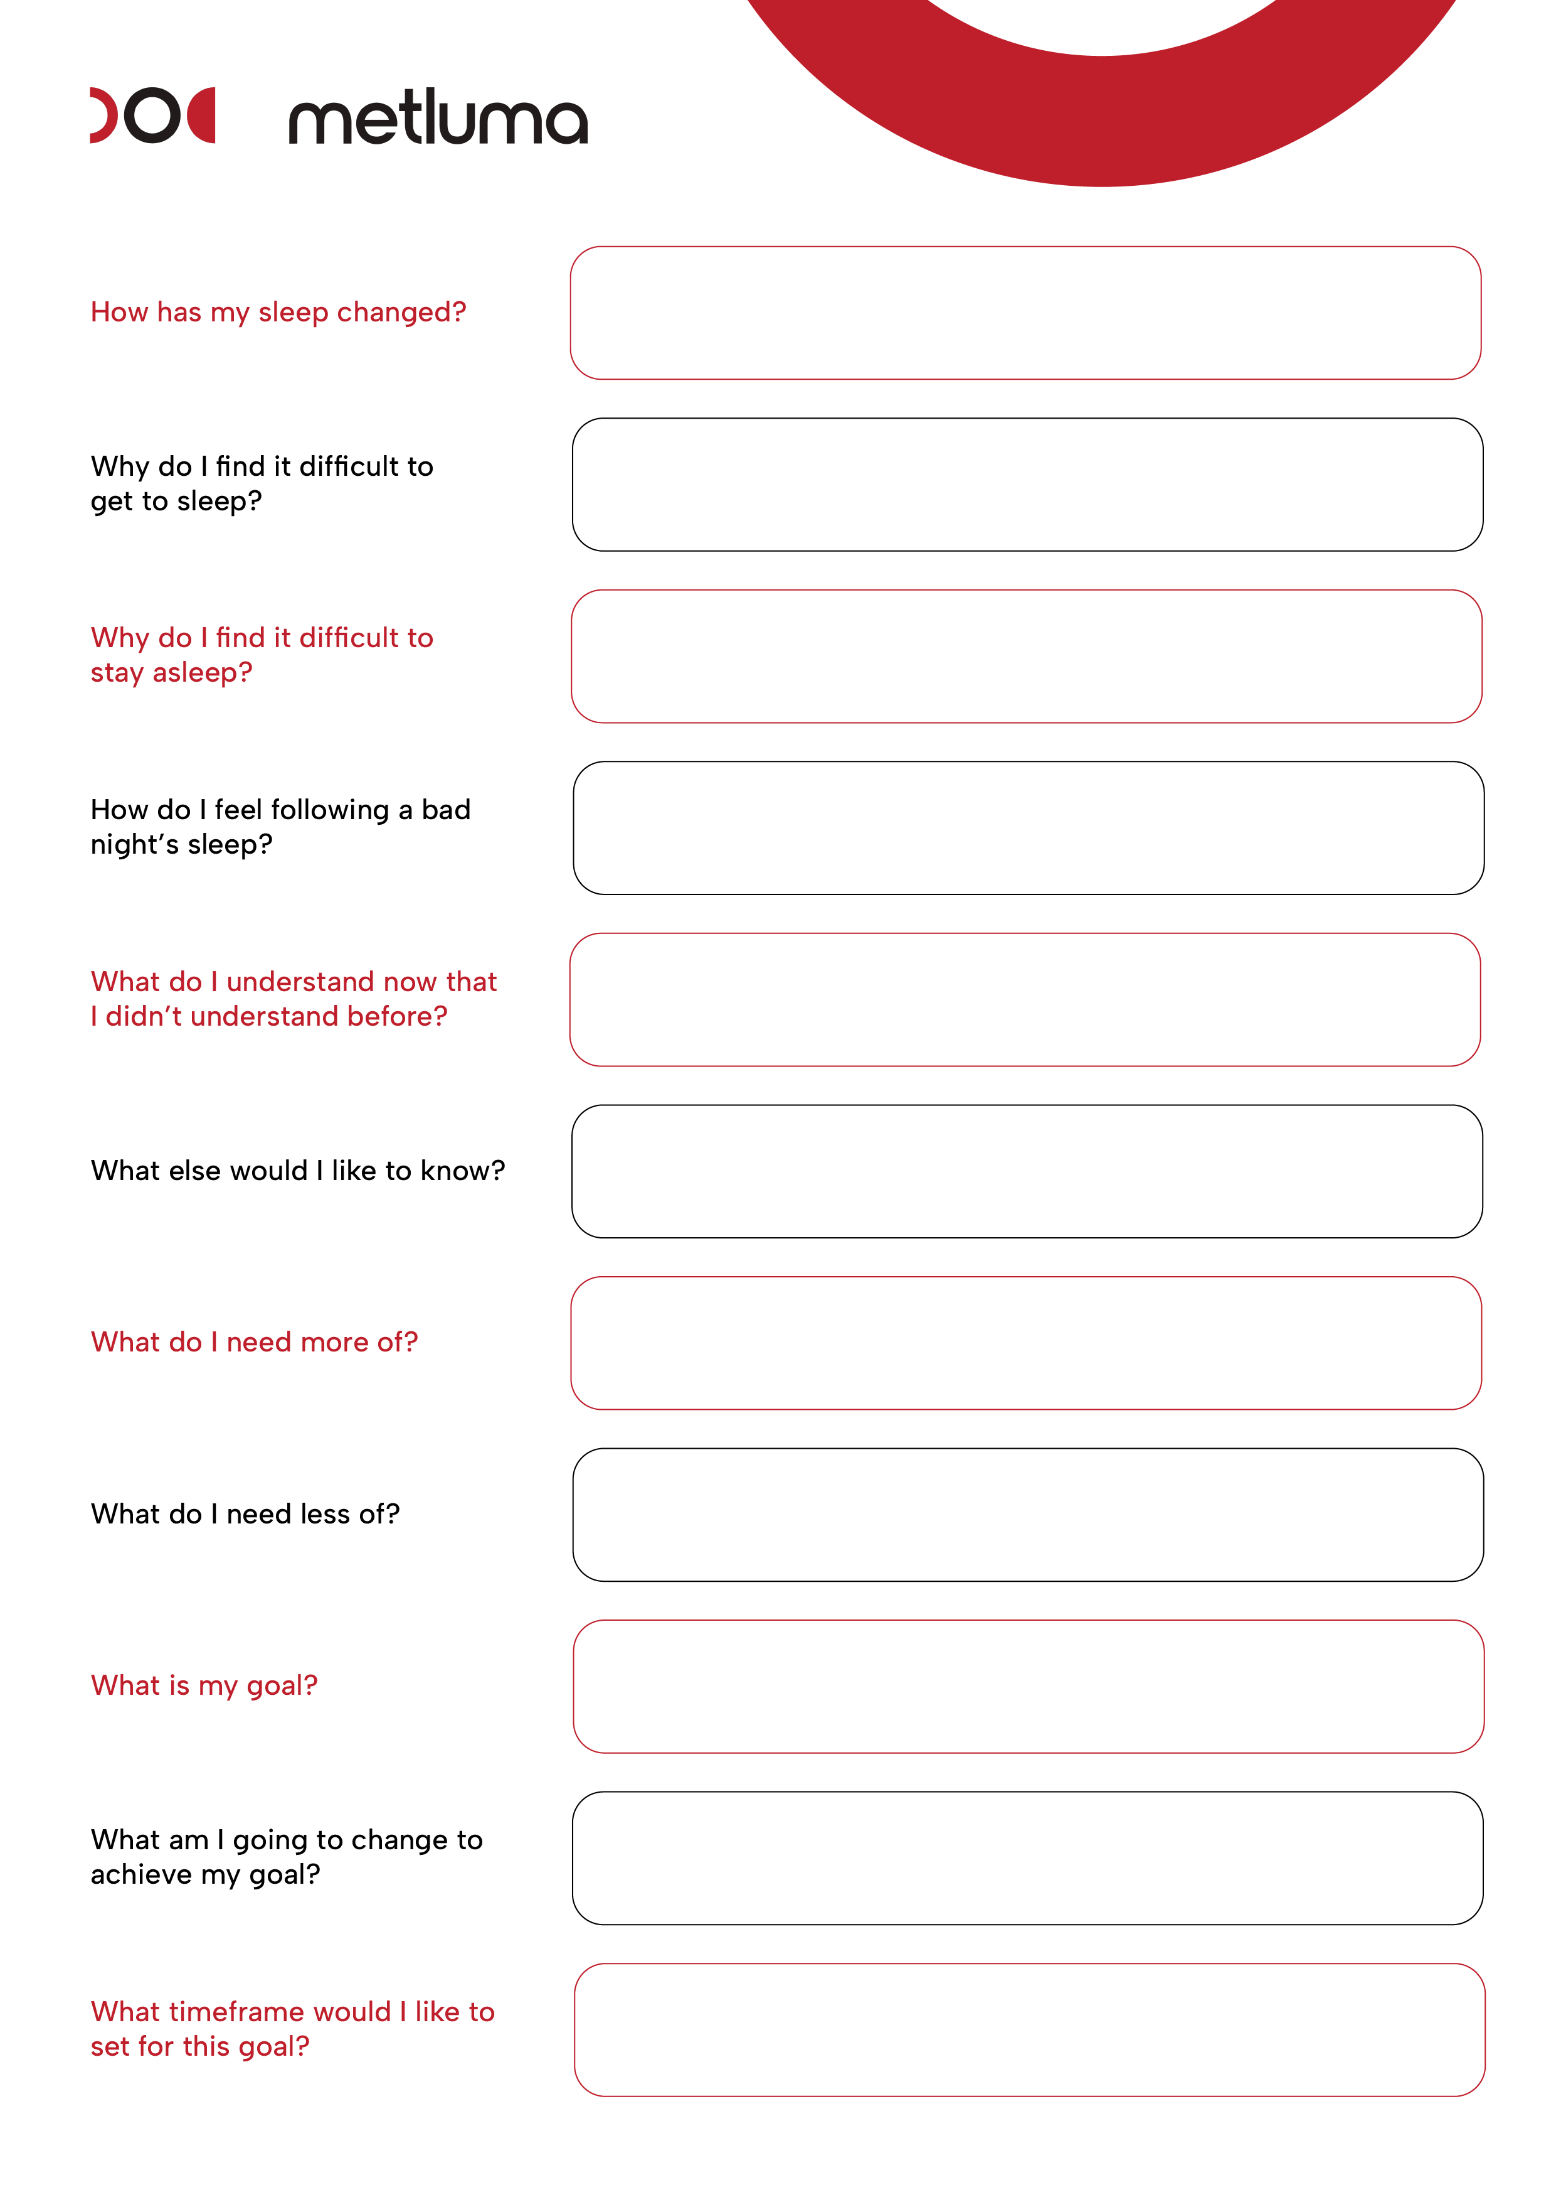

Click here.

Click here.

Click here.

Click here.

Click here.

Click here.

Click here.

Click here.

Click here.

Click here.

Click here.